Vocabulary
Extraneous Solution:

Solving Basic Absolute Equations: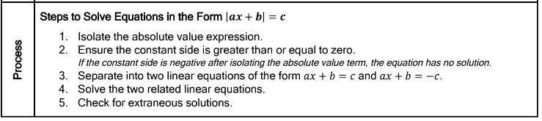
Examples: Solve the equation
1. $5\left|\frac{1}{2}a+6\right|-2=18$ 2. $-3\left|k-1\right|=12$ 3. $4-5\left|\frac{3}{4}m+12\right|=4$

4. What is the sum of the solutions to the equation of: $\left|-6x-4\right|=22$

5. What is the sum of the solutions to the equation of: $\left|2x+4\right|=26$

Solving Absolute Value Equations with variables on both sides:
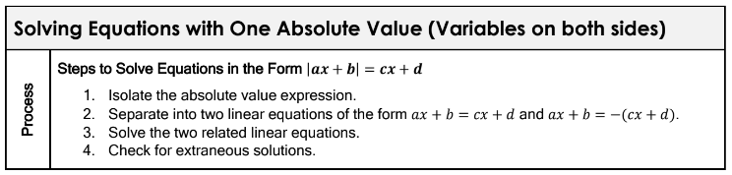
Examples: Solve the equation.
6. $6\left|c-3\right|=12c$ 7. $\left|5-\frac{3}{4}x\right|=\frac{1}{4}x+2$ 8. $\left|3n-2\right|+6=n$

Solving Equations with Absolute Values on both sides:
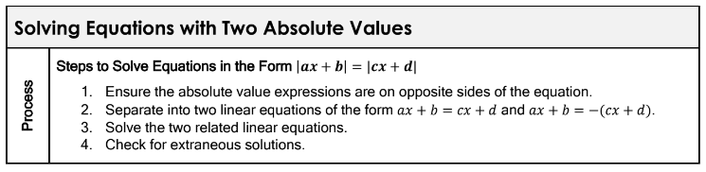
Examples: Solve the equation.
9. $\left|2p-1\right|=\left|5-p\right|$ 10. $\left|5-3r\right|=4\left|r+1\right|$ 11. $\left|2x+6\right|=2\left|5+x\right|$

